PENETRATION TESTING REPORT
FOOTPRINTING & NETWORK SCANNING PHASES
W2-PM-FINAL | CYBERSECURITY | NETWORKWALKS

Pentester Name  (Cybersecurity Professional) | Lawrence Aboagye Okai
Program/Batch | B082-Networkwalks
Date | 17 August 2026
Modules completed | W2-PM1 (Multiple Kali Tools)  W2-PM5 (Zenmap Scanning)
Client/Target | 1. Networkwalks (secured written permission already)  2. My own local LAN Network
Permission secured from client? | Yes
Phases covered | Phase 1: Reconnaissance & Footprinting  Phase 2: Scanning & Network Discovery  Phase 3-5: In Progress

1. Liability Disclaimer
I have performed these activities only on the systems & devices where I had secured written permission or the devices/systems that I own myself. All these materials are for education and research purpose only. Do not use anything from here to break the law. The instructor, the authors and Networkwalks are not responsible for what you do with this knowledge. Every action you take is your own responsibility. Misuse can lead to criminal charges, heavy fines, loss of your job and a permanent record. In most countries unauthorised access is a crime even when nothing is damaged.

2. Introduction
This report covers two main activities: footprinting the networkwalks.com domain using Kali Linux tools (W2-PM1) and scanning my local network using Zenmap (W2-PM5). The two activities demonstrate the different stages of reconnaissance, starting with gathering publicly available information and progressing to identifying active devices on a network.
The activities were completed as part of Week 2 of my Cybersecurity & Ethical Hacking internship at Networkwalks.
For the footprinting exercise, I used Kali Linux, while the network scanning exercise was performed on a Windows PC with Zenmap installed. For each activity, I documented the command used, results obtained, supporting screenshots, and a brief explanation of the security significance of each finding.
These exercises helped me understand how information gathered during reconnaissance can provide useful insights into a target environment and support further security assessment.

3. Tools Used
The table below lists each tool used in this report and its purpose.
Tool | Purpose
Kali Linux & Windows | Operating systems used for reconnaissance activities
WHOIS | Find domain registration details (owner, dates, name servers).
whatweb | Fingerprint web technologies (server, CMS, plugins, IP).
nslookup | Resolve the domain name to its IP address using DNS.
curl -I | Read the HTTP response headers of the website.
wafw00f | Detect whether a Web Application Firewall protects the site.
dnsrecon | Enumerate all DNS records (NS, MX, SPF, TXT, SRV).
Zenmap (Nmap GUI) | Scan the local subnet to find live hosts, IPs and MAC addresses.
Windows CMD | Local IP and MAC address identification

4. Activities Performed

4.1 Footprinting & Reconnaissance
I performed reconnaissance against the networkwalks.com domain using six Kali Linux tools: WHOIS, WhatWeb, Nslookup, Curl, Wafw00f and DNSRecon. Each tool was used to collect a different type of information about the target.
First, I used WHOIS to obtain publicly available domain registration information and identify the domain’s name servers. The results provided information about the domain registration and hosting infrastructure.
I then used WhatWeb to identify technologies used by the website. The results identified WordPress 7.0.4 and WP Download Manager 3.3.58, along with other information exposed by the website.
Using Nslookup, I resolved the domain name to its IP address. The provided result identified 192.232.216.135.
I used Curl with the -I option to inspect the HTTP response headers. This provided additional information about the web application and exposed the WordPress REST API endpoint /wp-json/.
Next, I used Wafw00f to determine whether a Web Application Firewall was protecting the website. The result identified ModSecurity (SpiderLabs).
Finally, I used DNSRecon to enumerate DNS records. The results provided information relating to name servers, mail servers, SPF/TXT records, service records and DNS software information.

4.2 Network Scanning with Zenmap
For the second activity, I used Zenmap to perform network discovery on my local network. The practical required me to identify my local IP address and subnet, discover live hosts, identify their IP and MAC addresses, and generate a network topology.
I first used the Windows ipconfig command to identify my local IP address and LAN subnet. I then entered the subnet into Zenmap and selected Ping Scan to identify active hosts.
The example results provided in the practical identified four live hosts:
- 10.0.0.1
- 10.0.0.2
- 10.0.0.3
- 10.0.0.5
The example results also included four MAC addresses.
- 52:54:00:12:35:00
- 08:00:27:50:FB:E3
- 52:54:00:12:35:00
- 08:00:27:5a:87:bc

After completing the scan, I opened the Topology section in Zenmap, enabled the legend and saved the network topology in PDF format as required by the practical task.
Note: The actual subnet, number of hosts and addresses should be replaced with the results from my own network when submitting the report.

5. Risk Analysis / Impact
Based on the information collected during the footprinting and network scanning activities, I identified the following potential risks.
# | Risk / Finding | Evidence / Observation | Potential Impact | Risk Level
1 | Web technology information exposed | WhatWeb identified WordPress and WP Download Manager | Attackers may use exposed technology/version information to identify software requiring further security review | ● Medium
2 | Server IP address identifiable | Nslookup resolved the domain to 192.232.216.135 | Provides information about the network location of the web service | ● Low
3 | HTTP technical information exposed | Curl returned HTTP response headers and exposed /wp-json/ | May assist technology fingerprinting and further enumeration | ● Low
4 | WAF technology identifiable | Wafw00f identified ModSecurity (SpiderLabs) | Reveals information about the web application’s security architecture | ● Low
5 | DNS infrastructure information exposed | DNSRecon identified DNS, mail and service-related records | DNS information can help build a broader infrastructure profile | ● Medium
6 | Multiple live hosts visible on local network | Zenmap identified four live hosts in the example network | Unknown or unauthorized devices may potentially be present on a network | ● Medium

Risk level key: ● Critical ● Medium ● Low
The risks above are observations from the footprinting and scanning exercises, not confirmed vulnerabilities.
The practical exercises primarily involved information gathering and host discovery. No exploitation or vulnerability validation was performed as part of these two modules.
Therefore, the presence of information such as a software version, IP address or DNS record does not by itself mean that the system is vulnerable. Further authorized security testing would be required to confirm any actual vulnerability.

6. Recommendations
Based on the observations from these activities, I recommend the following security improvements:
- Review publicly exposed technology information
Organizations should regularly review the information publicly available about their web technologies, CMS platforms, and plugins.
- Keep software updated
CMS platforms, plugins, frameworks, and other web technologies should be regularly updated and checked against current security advisories.
- Review HTTP headers
HTTP response headers should be reviewed to determine whether unnecessary technical information is being exposed.
- Review DNS records regularly
DNS records should be checked periodically to ensure that only required information and services are publicly exposed.
- Properly configure and monitor the WAF
The WAF (ModSecurity) should remain enabled, properly configured, and regularly monitored to help detect and blocks malicious requests.
- Perform regular internal network discovery
Organizations should periodically scan their authorized networks to identify active devices and maintain visibility of their network environment.
- Investigate unknown devices
Any unexpected device identified during network scanning should be investigated and verified to ensure it is authorized.
- Maintain network documentation
Network topology, devices, IP addresses, and related information should be properly documented and kept up to dated.
- Perform security testing with authorization
Reconnaissance and security scanning should only be performed against systems and networks where proper authorization has been obtained.

7. Conclusion
During Week 2 of my Cybersecurity & Ethical Hacking internship, I carried out practical exercises on footprinting, reconnaissance, and network scanning.
For the footprinting activity, I used six Kali Linux tools to gather information about the target domain. I learned how WHOIS provides domain information, WhatWeb identifies web technologies, Nslookup resolves domain names, Curl examines HTTP headers, Wafw00f detects web application firewalls, and DNSRecon gathers DNS information.
For the network scanning activity, I used Zenmap to examine my local network, identify active hosts, collect IP and MAC address information, and create a basic network topology.
These activities helped me understand the importance of information gathering in cybersecurity. I learned that security professionals can discover valuable information about a system before any exploitation is attempted by carefully analyzing publicly available information and network responses.
I also learned the importance of proper documentation and reporting. Cybersecurity findings should clearly explain what was done, what was discovered, the possible risks, and the recommended measures to address them.
Finally, I learned that reconnaissance and network scanning should always be conducted within an authorized scope. All the activities were performed as part of my assigned educational cybersecurity lab.

8. Evidence Collected

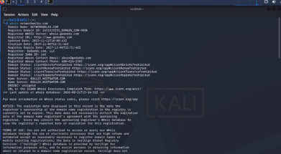

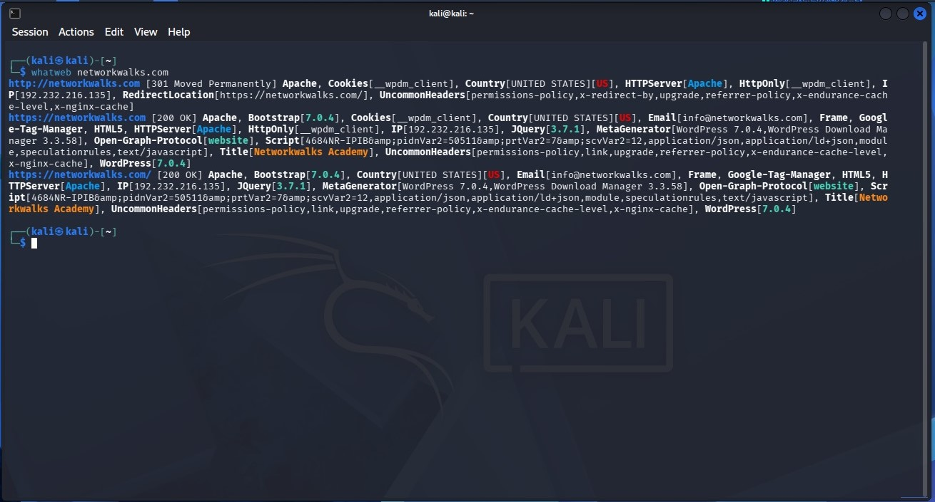

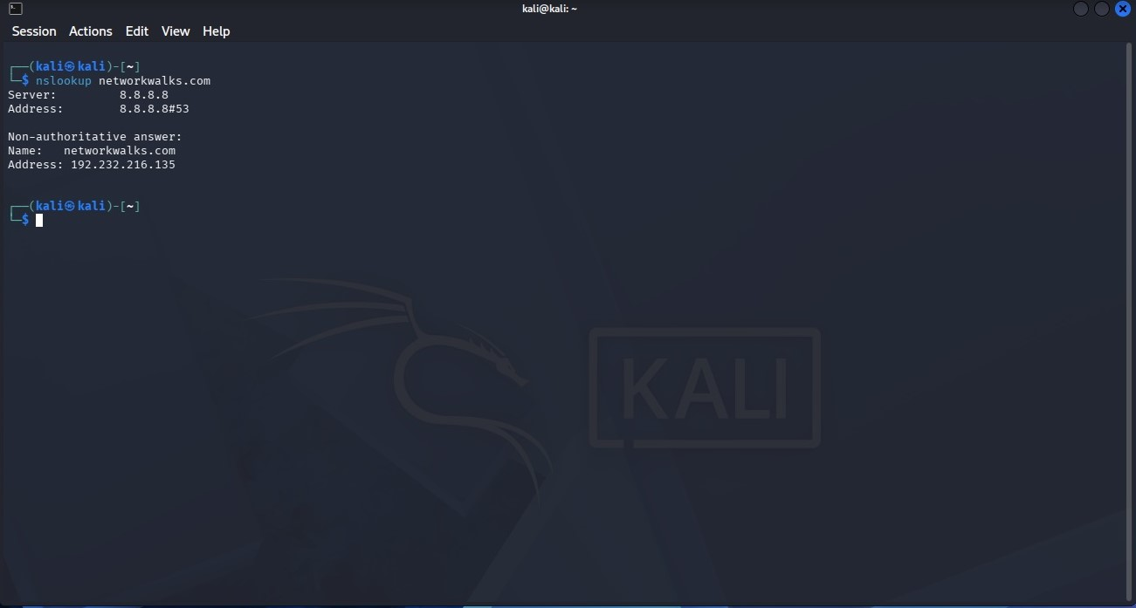

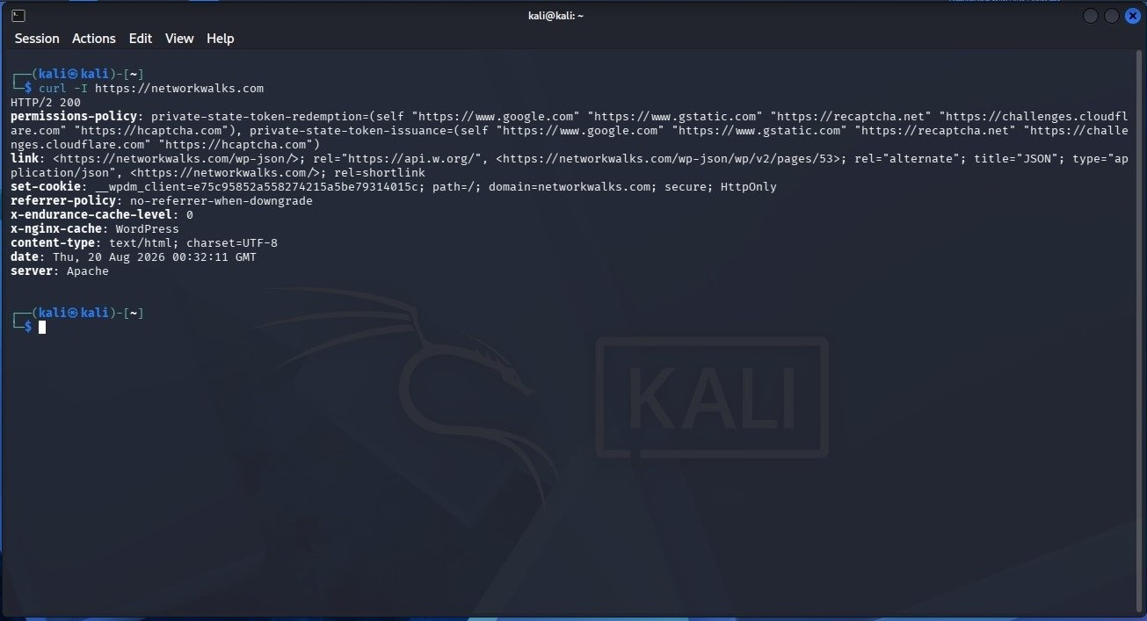

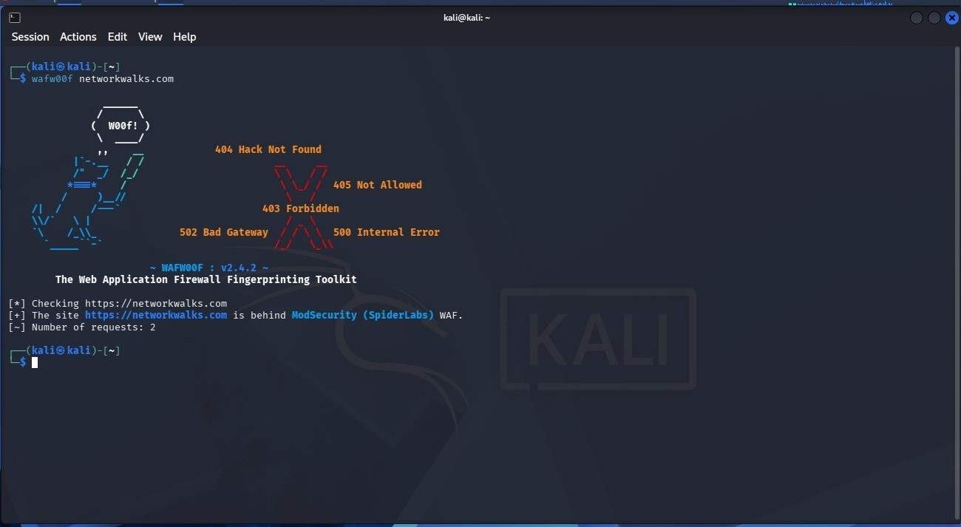

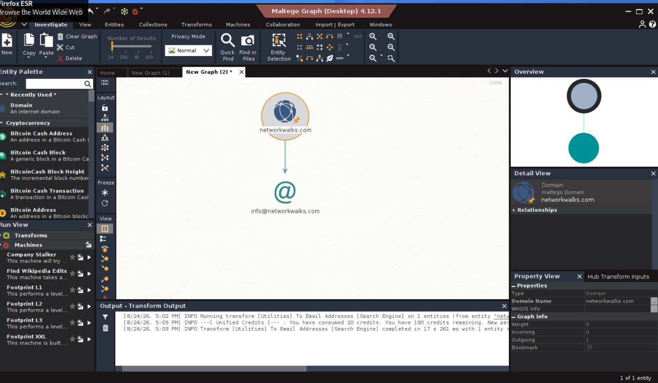

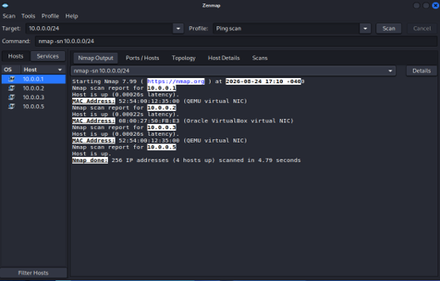

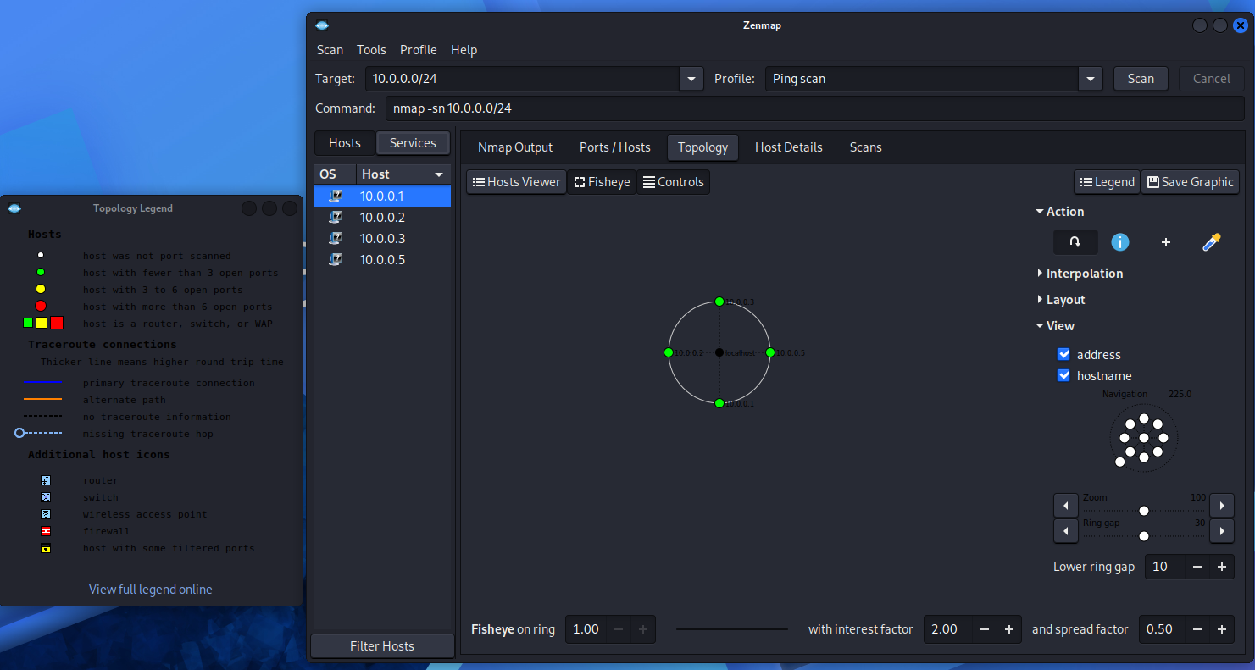

-End-

